✴

# Document an existing experience

**TIP**

As you add steps to the experience, move each these “Five Es” the left or right depending on the scenario you are documenting.

Narrow your focus to a specific scenario or process within an existing product or service. In the **Steps** row, document the step-by-step process someone typically experiences, then add detail to each of the other rows.

Customer experience journey map

Use this framework to better understand customer needs, motivations, and obstacles by illustrating a key scenario or process from start to finish.

When possible, use this map to document and summarize interviews and observations with real people rather than relying on your hunches or assumptions.

Created in partnership with

SCENARIO

**Browsing, booking, attending, and rating a local city tour**

**Steps**

What does the person (or group) typically experience?

## Interactions

What interactions do they have at each step along the way?

**People:** Who do they see or talk to?

**Places:** Where are they?

**Things:** What digital touchpoints or physical objects would they use?

# Entice

How does someone initially become aware of this process?

After the correct recognition of digits, the customer will be satisfied

Visit website

upload image

The customer navigates to the upload section of our website

The customer has to upload the image if he has the soft copy of the image.

Upload image section of the website

Scan image section of the website

Digitized output section of the website

# Enter

What do people experience as they begin the process?

### Experience the output

**Start uploading/ Scanning image**

#### The customer will view the digitized output

If the customer wants to upload the image, he will upload it or else he will scan it

Output section

Upload or scan image section of website

# Engage

In the core moments in the process, what happens?

Scan image

**Checking the image**

Checks whether customer has uploaded the correct handwritten image

Pop up message of website

**Process the image**

The customer has to scan the handwritten digits

After checking the image,it will start processing the image.

After successfull recognition of digits, the customer will be satisfied, since they got their recognized digits correctly

Output section of website

# Exit

What do people typically experience

as the process finishes?

**Leave the website**

After the correct recognition of digits, the customer will be satisfied

Interaction with the banker

# Extend

What happens after the experience is over?

**Personalized Recommendation**

After experiencing our user friendly website,the customer can share information with their friends and neighbours

Recommendation span across website

**Goals & motivations**

Help me to suggest others to make use of the website

Help me leave the website with good feelings and satisfaction.

Help me to feel confident about recognized digits

Help me to check whether the uploaded image is correct or not

Help me to recognize the digits

Help me to upload or scan the image

Help me to avoid wrong recognition of handwritten digits

Help me to identify handwritten digits

Help me to find the right website

At each step, what is a person’s primary goal or motivation? (“Help me...” or “Help me avoid...”)

## Positive moments

What steps does a typical person find enjoyable, productive, fun, motivating, delightful, or exciting?

Excitement for digit recognition

It's productive when the digits are recognized fastly

**It's excites when the digits are recognized correctly**

It's very essential to get correct recognition of digit

## Negative moments

People express a bit of fear of digits to be recognized correctly

People might feel difficult to upload/ scan the image

**Some people are unclear while uploading or scanning the image**

People feel peer pressure while the image is being processed

People may upload the blurred images

People express a bit of fear of digits to be recognized correctly

People sometimes upload wrong images

**We think people like these recommendations because they are satisfied**

**This application tends to be good, since the digits are recognized correctly**

People while leaving the application feels delighted

We get a satisfaction feeling after getting correct result

What steps does a typical person find frustrating, confusing, angering, costly, or time-consuming?

[**Share template feedback**](https://muralco.typeform.com/to/CiqaHVat?typeform-source=app.mural.co)

## Areas of opportunity

How might we make each step better? What ideas do we have? What have others suggested?

Can we get history of recognized digits

**How might we know that the customer feels good and satisfied ?**

Could we get any help during the process

Could we get a image what we uploaded

**Could we get a message when the image is recognized correctly**

Could we get a error message when wrong images uploaded

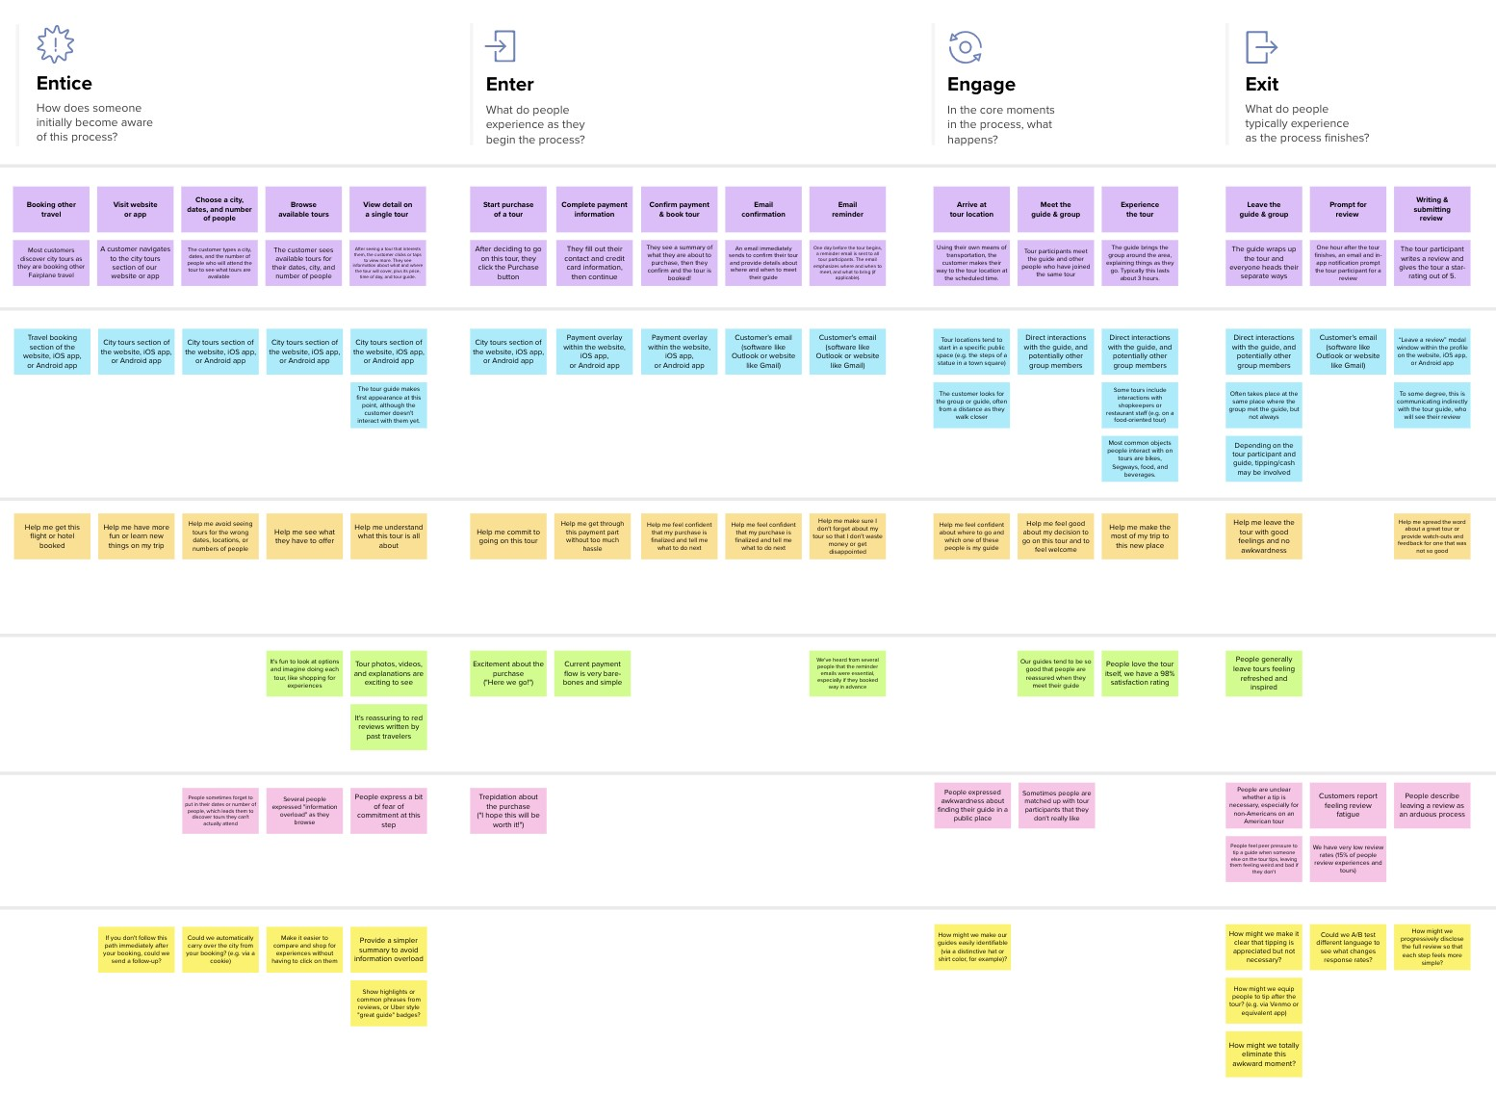

**Template**

**Need some inspiration?**

|  |  |  |  |  |  |  |  |  |
| --- | --- | --- | --- | --- | --- | --- | --- | --- |
|  |  |  |  |  |  |  |  |  |
|  |  |  |  | |  |  |  |  |

|  |  |  |  |  |  |  |  |  |
| --- | --- | --- | --- | --- | --- | --- | --- | --- |
|  |  |  |  |  |  |  |  |  |
|  |  |  |  | |  |  |  |  |

See a finished version of this template to kickstart your work.

[**Open example**](https://app.mural.co/template/f59f644b-b4b4-47b5-9ed6-3a8c71ceb612/896b31fe-5597-40ef-9b06-3811a1a45ace)